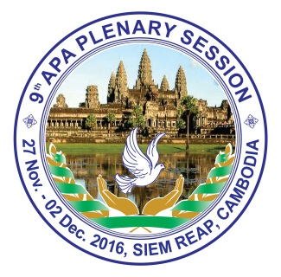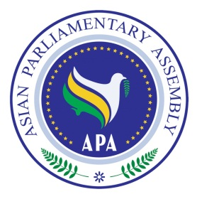**Asian Parliamentary Assembly (APA)**

**The 9th Plenary Session**

**27 November - 02 December 2016**

**Siem Reap, the Kingdom of Cambodia**

6

Speakers’ Pre-Registration Form

General Debate on Theme

**“Promoting Peace and Sustainable Development in Asia”**

**Country:…………………………………………………………………………………………**

|  |  |  |  |  |
| --- | --- | --- | --- | --- |
|  | Please circle on title | Family Name | Given Name(s) | Position |
| 1 | Mr./Mrs. |  |  |  |
| 2* | Mr./Mrs. |  |  |  |



**\*** Rule 27 of Chapter 7 of the Rules of procedure: No more than two representatives of each delegation may speak in the General Debate. Unless the Bureau decides otherwise, every delegation shall be entitled to 10 minutes speaking time in the General debate. When two speakers from the same delegation are registered for this debate, they shall share the speaking time in the most appropriate way.

**DATE: ................................................................ SIGNATURE: ..................................................................**

Kindly fill this form and return it by 6 p.m. (Phnom Penh time) at the latest on 29 November 2016 to the Host Secretariat at either:

Fax: (+855 23) 218 195 or Email: thulheang@gmail.com, [hokcscc@yahoo.com](mailto:hokcscc@yahoo.com), cambodia_apagroup@yahoo.com